1. **Write a C program to Graph traversal using Depth First Search.**

**PROGRAM:**

#include <stdio.h>

#include <stdlib.h>

#define MAX 100

int visited[MAX];

int adjMatrix[MAX][MAX];

int n;

void depthFirstSearch(int vertex) {

int i;

visited[vertex] = 1;

printf("%d ", vertex);

for (i = 0; i < n; i++) {

if (adjMatrix[vertex][i] && !visited[i]) {

depthFirstSearch(i);

}}}

int main() {

int i, j, startVertex;

printf("Enter the number of vertices: ");

scanf("%d", &n);

printf("Enter the adjacency matrix:\n");

for (i = 0; i < n; i++) {

for (j = 0; j < n; j++) {

scanf("%d", &adjMatrix[i][j]);

}}

for (i = 0; i < n; i++) {

visited[i] = 0;

}

printf("Enter the starting vertex for DFS: ");

scanf("%d", &startVertex);

printf("Depth First Search starting from vertex %d: ", startVertex);

depthFirstSearch(startVertex);

return 0;

}

**INPUT:**

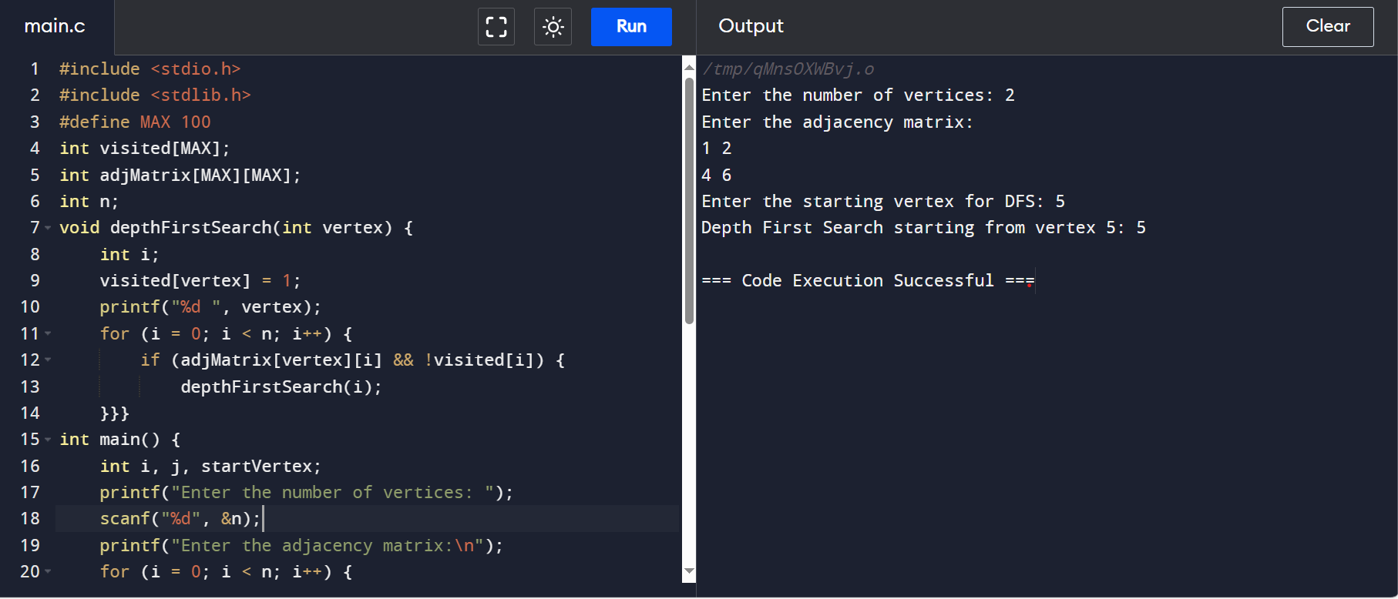

**OUTPUT:**

